How to create AxF materials for Unity

(using the AxF Extractor)

First things first: the source code for the AxF Extractor can be found here 🡺 <https://github.com/Patapom/GodComplex/tree/master/Tools/AxFExtractor>

# Tested packages

The following packages have been successfully exported and tested in Unity:

* **AxFSvbrdf_1_0_Dir, AxFSvbrdf_1_1_Dir, AxFSvbrdfNoRefract_1_3_Dir**, containing only SVBRDF materials.

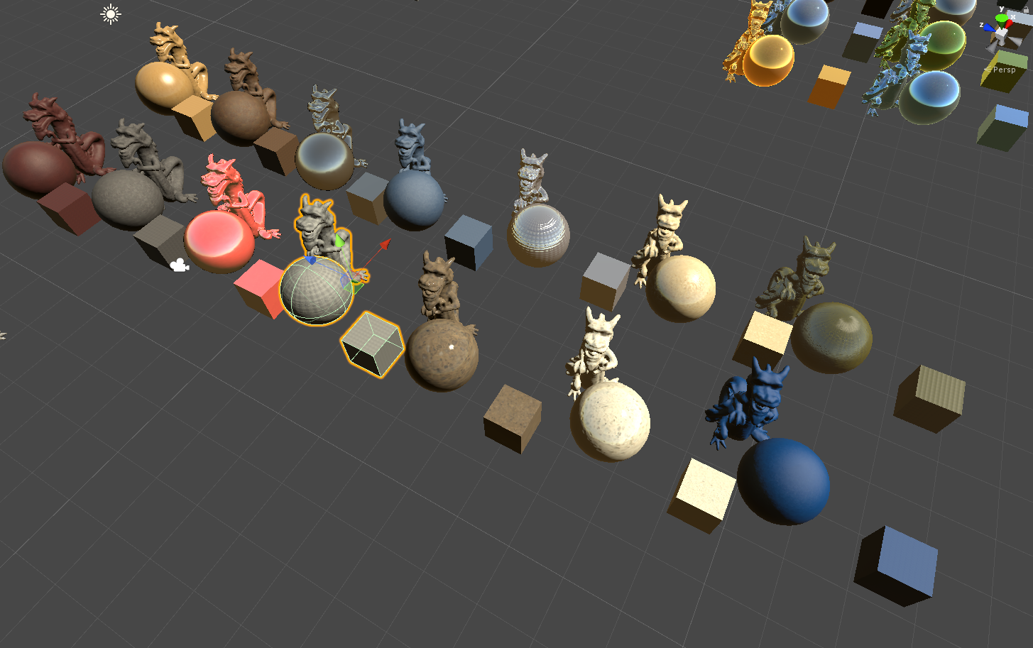

* **Volkswagen**, containing 3 SVBRDF materials + 1 car paint material

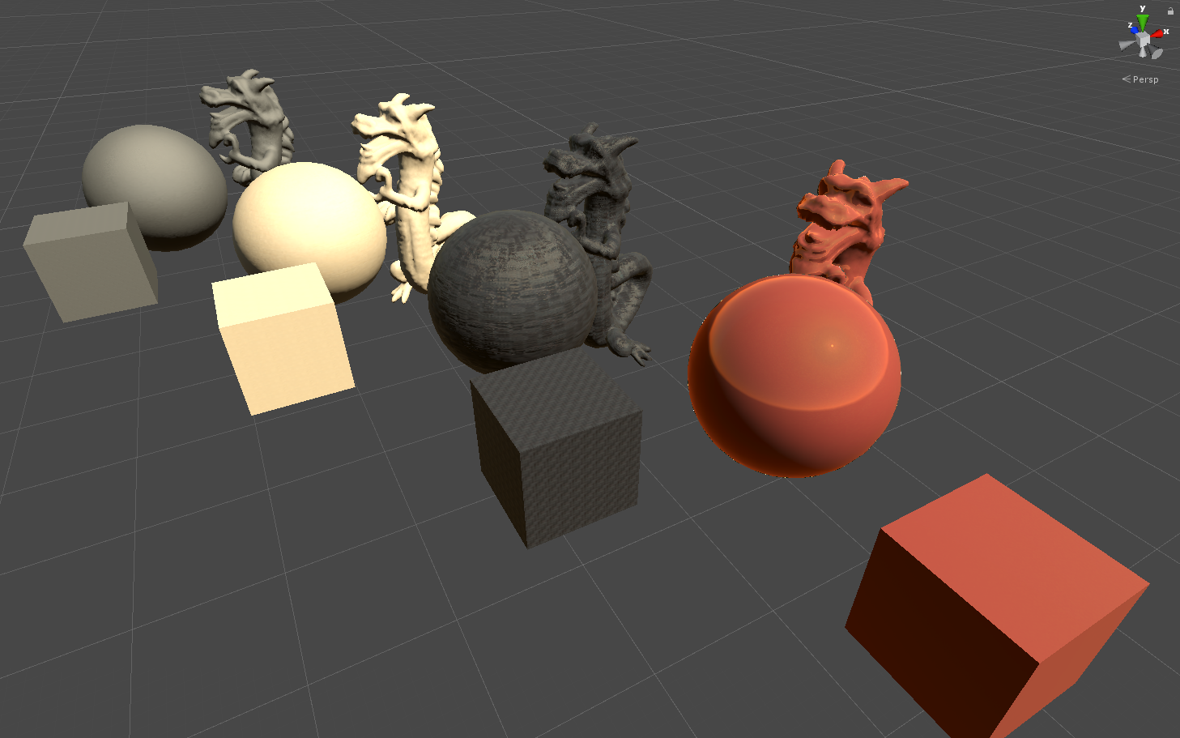

* **AxFCarPaintRefract_1_2_Dir**, containing only car paint materials

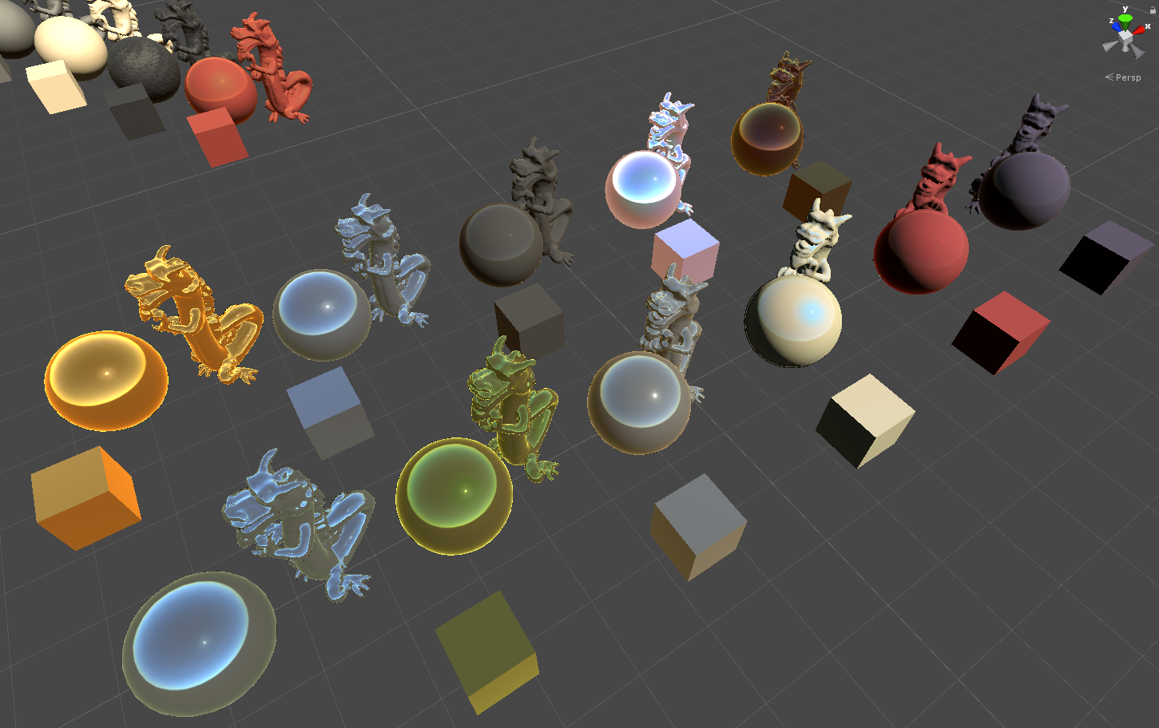

# Extracting an AxF Material

At the moment, only SVBRDF and Car Paint materials are supported (i.e. no BTF then).

Open AxFExtractor.exe and simply choose an AxF file to open:

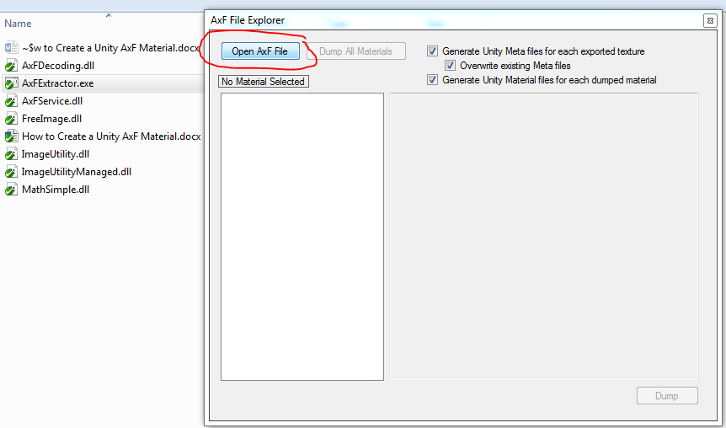

Then click the “Dump” button and choose a folder where to export the material files:

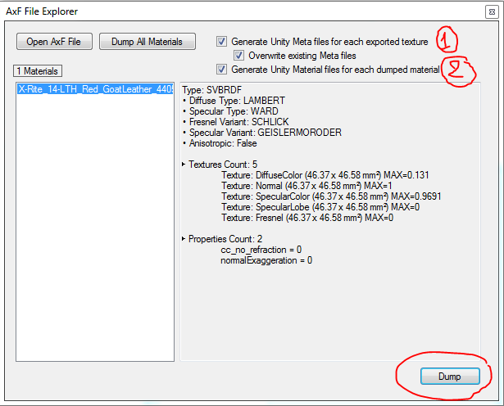

If you enabled (1) then the *.META files required by Unity will be generated as well (recommended so the generated material references the proper texture GUIDs)

If you enabled (2) then the *.MAT file representing a Unity material will be generated, with the proper connections to the shader variables, **\*EXCEPT FOR CAR PAINT MATERIALS AS EXPLAINED BELOW\***.

# Using SVBRDF Materials

In Unity, you simply need to drag’n drop the material file onto an object to see it working immediately.

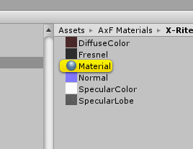

# Using Car Paint Materials

At the moment, the generated material is not complete unless you properly generate the Texture2DArray for the “Flakes BTF” texture.

If everything worked perfectly you should have a folder with the following files (except for the materials that only provide a 1x1 flakes texture):



The slices of the flakes texture are packed into an atlas named “BTFFlakes“, accompanied by all its mips.

You need to open the dialog box editor ***Window > Render Pipeline > Created Texture2DArray*** and drag’n drop the BTFFlakes texture as source:

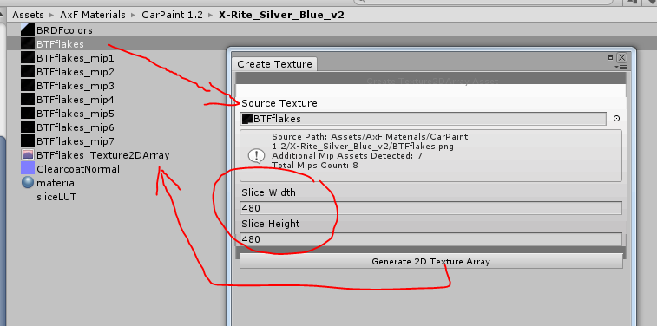

The size of the slices should always be 480x480 but it may vary (not encountered), the sizes are given by the AxF Extractor description window anyway:

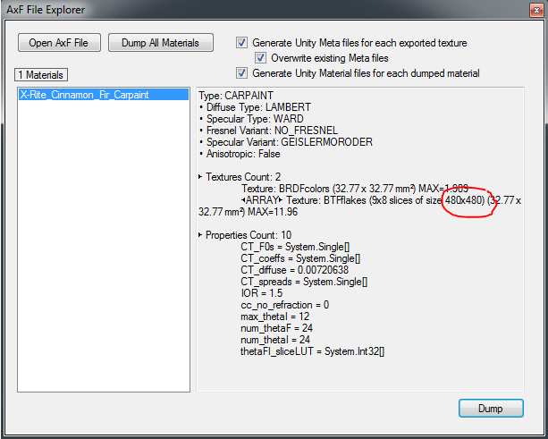

Then to complete the car paint material, open the material in the inspector and drag’n drop the generated BTFFlakes_Texture2DArray asset onto the proper texture slot:

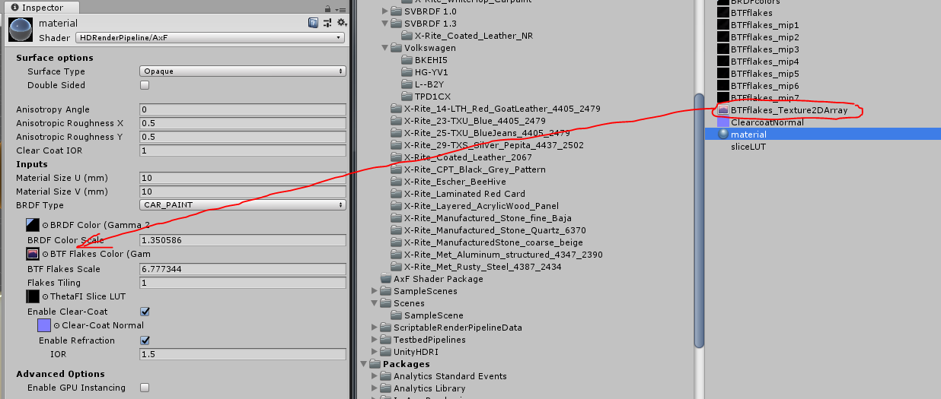

And you’re done! Simply assign the material to an object, as for the SVBRDF case to use it.